# SUPPLEMENTAL MATERIAL

running head: Modeling SF excretion in *ex vivo* machine-perfused livers

**Assessing the degree of hepatic ischemia-reperfusion injury using physiologically-based pharmacokinetic modeling of sodium fluorescein disposition in *ex vivo* machine-perfused livers**

Christopher E. Monti1,2, Seung-Keun Hong3, Said H. Audi1,4, Amit Joshi1, Scott S. Terhune2, Joohyun Kim3, Ranjan K. Dash1,4,5

1Department of Biomedical Engineering, Medical College of Wisconsin, Milwaukee, WI

2Department of Microbiology and Immunology, Medical College of Wisconsin, Milwaukee, WI

3Division of Transplant Surgery, Department of Surgery, Medical College of Wisconsin, Milwaukee, WI

4Department of Biomedical Engineering, Marquette University, Milwaukee, WI

5Department of Physiology, Medical College of Wisconsin, Milwaukee, WI

Correspondence: *Ranjan K. Dash (rdash@mcw.edu), Joohyun Kim (jokim@mcw.edu)*

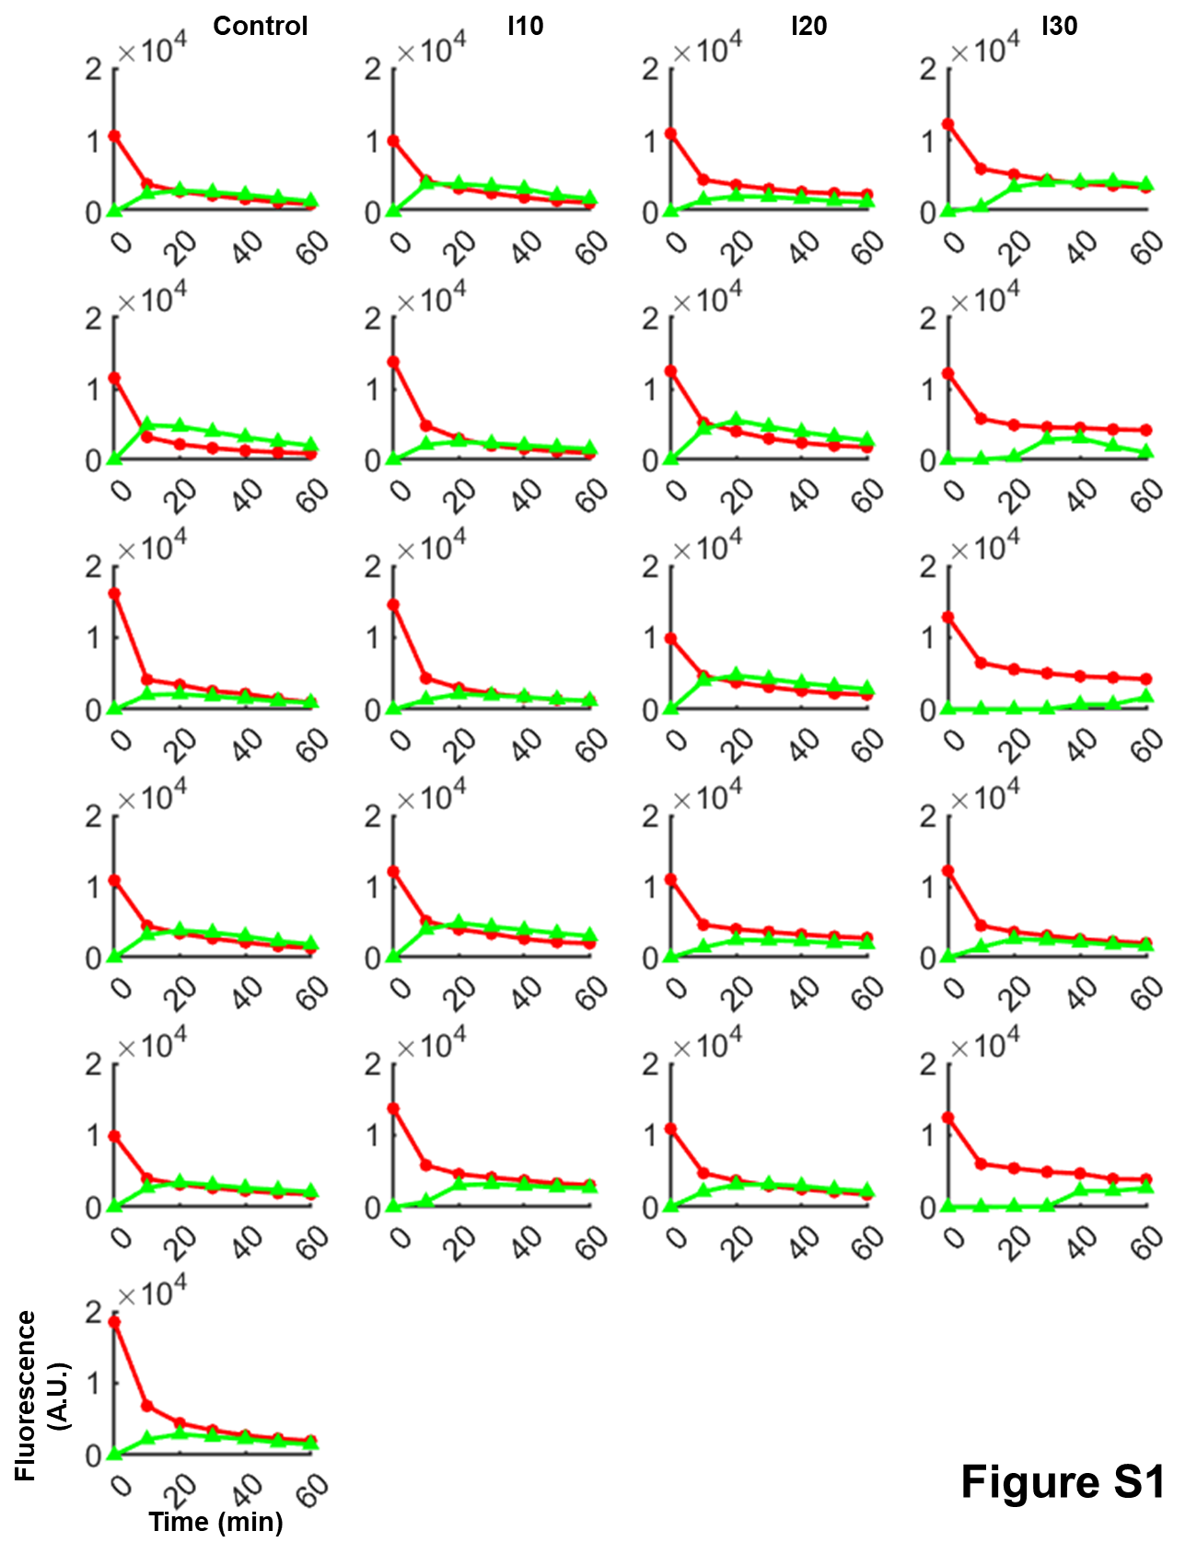

**Figure S1.** Individual SF fluorescence measurements in the perfusate and bile obtained in Dr. Joohyun Kim Laboratory (Froedtert Hospital Division of Transplant Surgery).

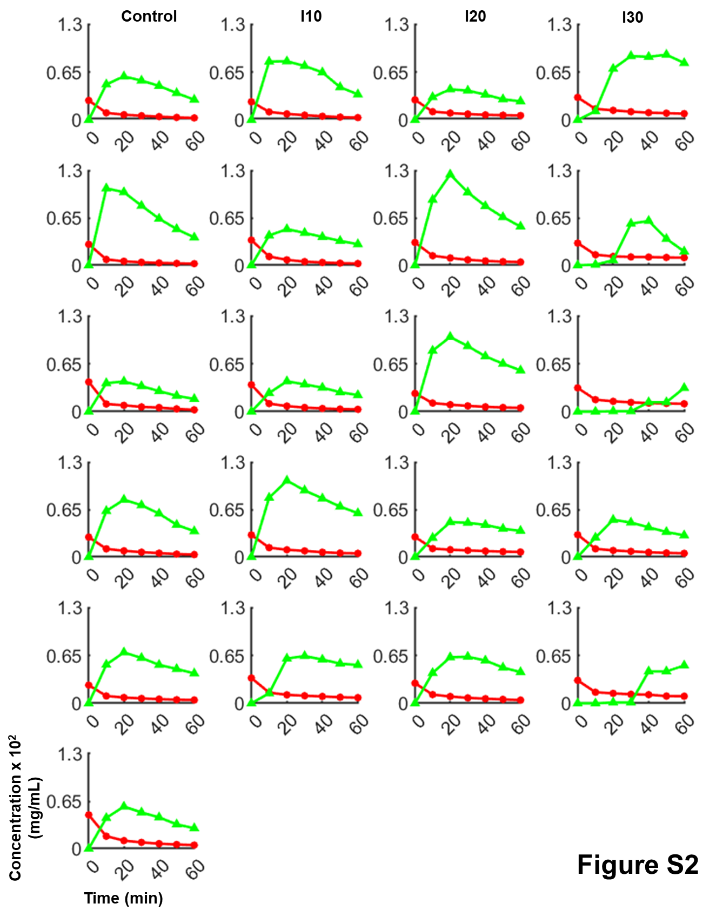

**Figure S2.** Individual SF concentration measurements in the perfusate and bile generated using the SF fluorescence datasets from **Fig. S1** and calibration curves in **Fig. 2A**.

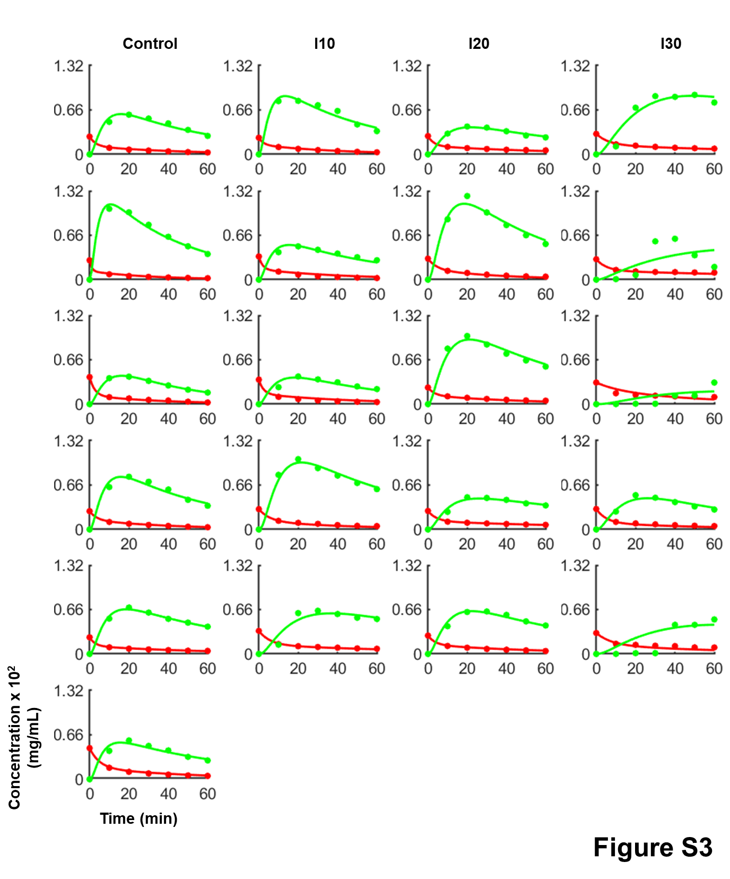

**Figure S3.** Individual fits of the 3-parameter PBPK ODE model to the datasets in **Fig. S2**.

**Table S1.** Individual fitting parameter values.

|  |  |  |  |  |  |  |  |  |  |  |  |  |  |
| --- | --- | --- | --- | --- | --- | --- | --- | --- | --- | --- | --- | --- | --- |
| Condition | Replicate | Rat Weight (kg) | Liver Weight (g) | *VR,1* (mL) | *VR,2* (mL) | *VS* (mL) | *VH* (mL) | *VB* (mL) | Perfusate Flow Rate (mL/min) | Bile Flow Rate (mL/min) | *Vmax,2* (mg/min) | *Vmax,3,SF* x 104 (mg/min) | *α (F/Kmix)* (Unitless) |
| Control | 1 | 0.3020 | 15.60 | 45.77 | 54.23 | 2.80 | 12.79 | 0.06 | 25.00 | 0.01 | 0.17 | 1.69 | 2.84 |
| 2 | 0.3250 | 14.80 | 45.15 | 54.84 | 2.66 | 12.14 | 0.06 | 25.00 | 0.02 | 0.24 | 4.07 | 1.01 |
| 3 | 0.3140 | 16.40 | 31.14 | 68.86 | 2.95 | 13.45 | 0.07 | 25.00 | 0.01 | 0.21 | 1.06 | 2.77 |
| 4 | 0.3288 | 14.00 | 48.41 | 51.59 | 2.52 | 11.48 | 0.06 | 25.00 | 0.01 | 0.18 | 2.04 | 3.43 |
| 5 | 0.3030 | 15.60 | 49.13 | 50.87 | 2.81 | 12.79 | 0.06 | 18.00 | 0.01 | 0.13 | 1.53 | 1.78 |
| 6 | 0.4000 | 15.28 | 34.59 | 65.41 | 2.75 | 12.53 | 0.06 | 23.00 | 0.02 | 0.14 | 1.80 | 4.88 |
| I10 | 1 | 0.3585 | 16.00 | 58.12 | 41.88 | 2.88 | 13.12 | 0.06 | 25.00 | 0.02 | 0.20 | 2.84 | 2.07 |
| 2 | 0.4010 | 20.00 | 46.50 | 53.50 | 3.60 | 16.40 | 0.08 | 15.00 | 0.01 | 0.18 | 1.68 | 1.17 |
| 3 | 0.4100 | 22.00 | 44.99 | 55.01 | 3.96 | 18.04 | 0.09 | 20.00 | 0.01 | 0.17 | 1.09 | 1.63 |
| 4 | 0.2730 | 16.80 | 36.13 | 63.87 | 3.02 | 13.78 | 0.07 | 18.00 | 0.01 | 0.16 | 2.72 | 4.33 |
| 5 | 0.3500 | 20.50 | 40.81 | 59.19 | 3.69 | 16.81 | 0.08 | 14.00 | 6.00E-03 | 0.09 | 0.81 | 3.05 |
| I20 | 1 | 0.3350 | 20.00 | 49.19 | 50.81 | 3.60 | 16.40 | 0.08 | 16.00 | 0.01 | 0.13 | 0.95 | 1.66 |
| 2 | 0.3390 | 18.20 | 43.39 | 56.61 | 3.28 | 14.92 | 0.07 | 22.00 | 0.01 | 0.23 | 3.42 | 4.14 |
| 3 | 0.3230 | 16.00 | 52.29 | 47.71 | 2.88 | 13.12 | 0.06 | 18.57 | 8.00E-03 | 0.16 | 1.90 | 2.23 |
| 4 | 0.2730 | 16.20 | 46.99 | 53.00 | 2.92 | 13.28 | 0.06 | 18.00 | 8.00E-03 | 0.07 | 0.77 | 2.72 |
| 5 | 0.3500 | 18.40 | 51.30 | 48.70 | 3.31 | 15.09 | 0.07 | 19.00 | 9.00E-03 | 0.13 | 1.34 | 2.46 |
| I30 | 1 | 0.3670 | 19.60 | 48.11 | 51.88 | 3.53 | 16.07 | 0.08 | 15.86 | 3.00E-03 | 0.07 | 0.75 | 3.57 |
| 2 | 0.3700 | 20.00 | 48.72 | 51.28 | 3.60 | 16.40 | 0.08 | 15.00 | 2.00E-03 | 0.06 | 0.20 | 2.73 |
| 3 | 0.3200 | 20.00 | 39.82 | 60.18 | 3.60 | 16.40 | 0.08 | 8.00 | 9.60E-04 | 0.26 | 0.17 | 5.00 |
| 4 | 0.2460 | 19.60 | 32.26 | 67.74 | 3.53 | 16.07 | 0.08 | 22.00 | 8.00E-03 | 0.14 | 1.02 | 5.00 |
| 5 | 0.3090 | 18.40 | 39.75 | 60.25 | 3.31 | 15.09 | 0.07 | 16.00 | 2.00E-03 | 0.12 | 0.28 | 5.00 |



**Figure S4.** Grading of IRI from liver tissue with increasing WIT (control: 0 min WIT; I10, I20, I30: 10, 20, 30 min WIT, respectively) using the Suzuki scoring method (**A**) and grading for selected additional findings (**B**-**D**) (1). **A.** Total Suzuki score vs. WIT. **B.** Score for inflammation and necrosis vs. WIT. **C.** Score for hepatocellular congestion vs. WIT. **D.** Score for macrovesicular steatosis vs. WIT. A Kruskall-Wallis, nonparametric test with correction for multiple comparisons was used to analyze between groups. ns: not significant. Note that statistical analysis demonstrated no significant difference (α = 0.05) between groups for any histologic scoring criteria (**A.**-**D.**). See **Table S2** for raw histologic grading.

**Table S2.** Raw histologic grading values

|  |  |  |  |  |  |  |  |  |
| --- | --- | --- | --- | --- | --- | --- | --- | --- |
|  |  | IRI Assessment | | Additional Findings | | | | |
| Condition | Replicate | Inflammation + Necrosis (0-4) | IRI Injury (y [1] or n [0]) | Congestion (0-4) | Ballooning (0-4) | Macrovesicular Steatosis (0-4) | Cholestasis (0-4) | Comments |
| WIT = 0 min | 1 | 0 | n (0) | 2 | 0 | 0 | 0 |  |
| 2 | 0 | n (0) | 1 | 0 | 0 | 0 |  |
| 3 | 0 | n (0) | 0 | 0 | 1 | 0 |  |
| 4 | 0 | n (0) | 3 | 0 | 2 | 0 |  |
| 5 | 0 | n (0) | 1 | 0 | 0 | 0 |  |
| 6 | 0 | n (0) | 2 | 0 | 1 | 0 |  |
| WIT = 10 min | 1 | 0 | n (0) | 2 | 0 | 0 | 0 |  |
| 2 | 0 | n (0) | 3 | 0 | 1 | 0 | Bacterial colonization + within some veins, impending IRI? |
| 3 | 0 | n (0) | 1 | 0 | 1 | 0 |  |
| 4 | 1 | n (0) | 1 | 0 | 1 | 0 | Bacterial colonization + within some veins, impending IRI? |
| 5 | 0 | n (0) | 2 | 0 | 1 | 0 | Bacterial colonization + within some veins, impending IRI? |
| WIT = 20 min | 1 | 1 | n (0) | 0 | 0 | 0 | 0 |  |
| 2 | 3 | y (1) | 3 | 0 | 0 | 0 | Pattern of IRI - Necrosis without inflammation |
| 3 | 3 | y (1) | 3 | 0 | 0 | 0 | Pattern of IRI - Necrosis without inflammation |
| 4 | 0 | n (0) | 1 | 0 | 0 | 0 |  |
| 5 | 0 | n (0) | 2 | 0 | 1 | 0 | Bacterial colonization + within some veins, impending IRI? |
| WIT = 30 min | 1 | 1 | n (0) | 3 | 0 | 1 | 0 | Bacterial colonization + within some veins, impending IRI? |
| 2 | 1 | n (0) | 3 | 0 | 2 | 0 | Bacterial colonization ++ within some veins, impending IRI? |
| 3 | 0 | n (0) | 3 | 0 | 3 | 0 | Bacterial colonization +++ within some veins |
| 4 | 0 | n (0) | 1 | 0 | 0 | 0 |  |
| 5 | 0 | n (0) | 2 | 0 | 1 | 0 |  |

References

1. **Sosa RA, Zarrinpar A, Rossetti M, Lassman CR, Naini BV, Datta N, Rao P, Harre N, Zheng Y, Spreafico R, Hoffmann A, Busuttil RW, Gjertson DW, Zhai Y, Kupiec-Weglinski JW, and Reed EF**. Early cytokine signatures of ischemia/reperfusion injury in human orthotopic liver transplantation. *JCI Insight* 1: e89679, 2016.